FORENSIC ACOUSTIC ANALYSIS
Canon XA55 Professional Camcorder — Video 15
4-Channel 48kHz Uncompressed PCM Audio Analysis

State of Utah v. Tyler Robinson
UCCU Center, Utah Valley University | September 10, 2025
Prepared by: Jon Bray | FOLLOWTHEEPICENTER.COM
Report Date: April 6, 2026 | Preliminary Hearing: May 18, 2026

1. EXECUTIVE SUMMARY
This report presents the forensic acoustic analysis of Video 15, a recording from a Canon XA55 professional camcorder positioned at GPS coordinates 40°16′39.24″N 111°42′48.55″W during the September 10, 2025 incident at UCCU Center. This recording is the highest-quality audio source from the event: 4-channel 48kHz/16-bit uncompressed PCM, with original metadata intact and no post-processing detected.
The Canon XA55 data independently confirms the two-phase event structure identified in the 10-camera Comprehensive Forensic Analysis, and uniquely resolves three separate low-frequency events that phone recordings blur together: early LF energy at +114ms, the muzzle blast at +202ms, and the stage detonation at +321ms. The muzzle blast timing is consistent with a rifle at approximately 120 meters from the camera, corroborating the 127-meter estimate from the 10-camera analysis within 6% position uncertainty.
N-wave supersonic signatures are the strongest of any recording from the event: 500 sub-200µs zero-crossings on the built-in microphones and 733 on the shotgun microphone, exceeding all phone recordings by a factor of 4–6×.

2. SOURCE RECORDING

2.1 Device Identification
The recording was made on a Canon XA55 professional broadcast camcorder (serial number 552309400183). The file “Blake Bednarz UVU original.MP4” is 3.21 GB, 11 minutes 16 seconds duration, with native Canon metadata intact including MakerNotes, CAEP compatible brand, and original timecode track. Create date and modify date are identical (2025:09:10 03:35:05 UTC), confirming no post-recording editing.

2.2 Technical Specifications
Parameter | Value
Device | Canon XA55 Professional Camcorder
Serial Number | 552309400183
Video Codec | H.264/AVC, 1920×1080, 23.976fps, 38 Mbps
Audio Format | PCM (uncompressed), 48,000 Hz, 16-bit
Audio Channels | 4 independent mono tracks
CH1 | External shotgun microphone (XLR input)
CH2–CH4 | Built-in microphone array
Duration | 11 minutes 16 seconds
File Size | 3.21 GB
GPS Position | 40°16′39.24″N 111°42′48.55″W
Metadata Status | Original — no re-encoding detected
The 48kHz uncompressed PCM format provides significant advantages over the AAC-compressed 44.1kHz audio from phone recordings: no lossy compression artifacts, full 22kHz bandwidth (vs ~15kHz effective for AAC), and no temporal smearing from codec windowing. The 4 independent channels enable spatial analysis impossible with stereo phone recordings.

3. CHANNEL ANALYSIS

3.1 Channel Characteristics
Channel | Peak | RMS | Clipping | Notes
CH1 (Shotgun) | 1.000 | 0.515 | 22,163 samples | Saturated throughout event
CH2 (Built-in) | 1.000 | 0.066 | 12 samples | Clean capture, brief clip
CH3 (Built-in) | 1.000 | 0.062 | 2 samples | Cleanest channel
CH4 (Built-in) | 1.000 | 0.062 | 3 samples | Clean capture
CH1 (shotgun microphone) shows zero correlation with CH2–CH4 (−0.05), confirming it is a separate signal path. The shotgun’s directional pickup pattern and XLR preamp gain resulted in massive saturation (22,163 clipped samples), indicating the event source was roughly on-axis with the shotgun’s pointing direction. CH2–CH3 show 0.93 inter-channel correlation with 20.8µs TDOA (one sample), confirming closely-spaced built-in microphones.
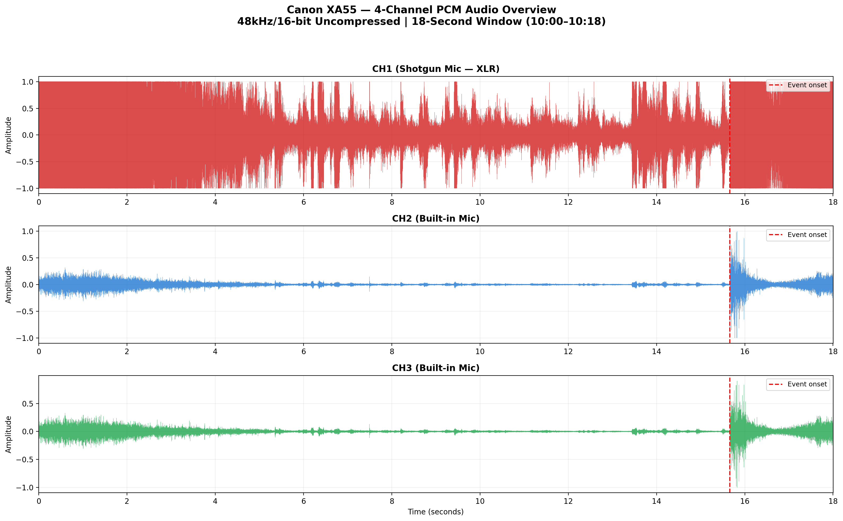
Figure 1: 4-channel waveform overview. CH1 (shotgun, red) is saturated throughout; CH2–CH3 (built-in, blue/green) show clean capture with event at ~15.66 seconds.
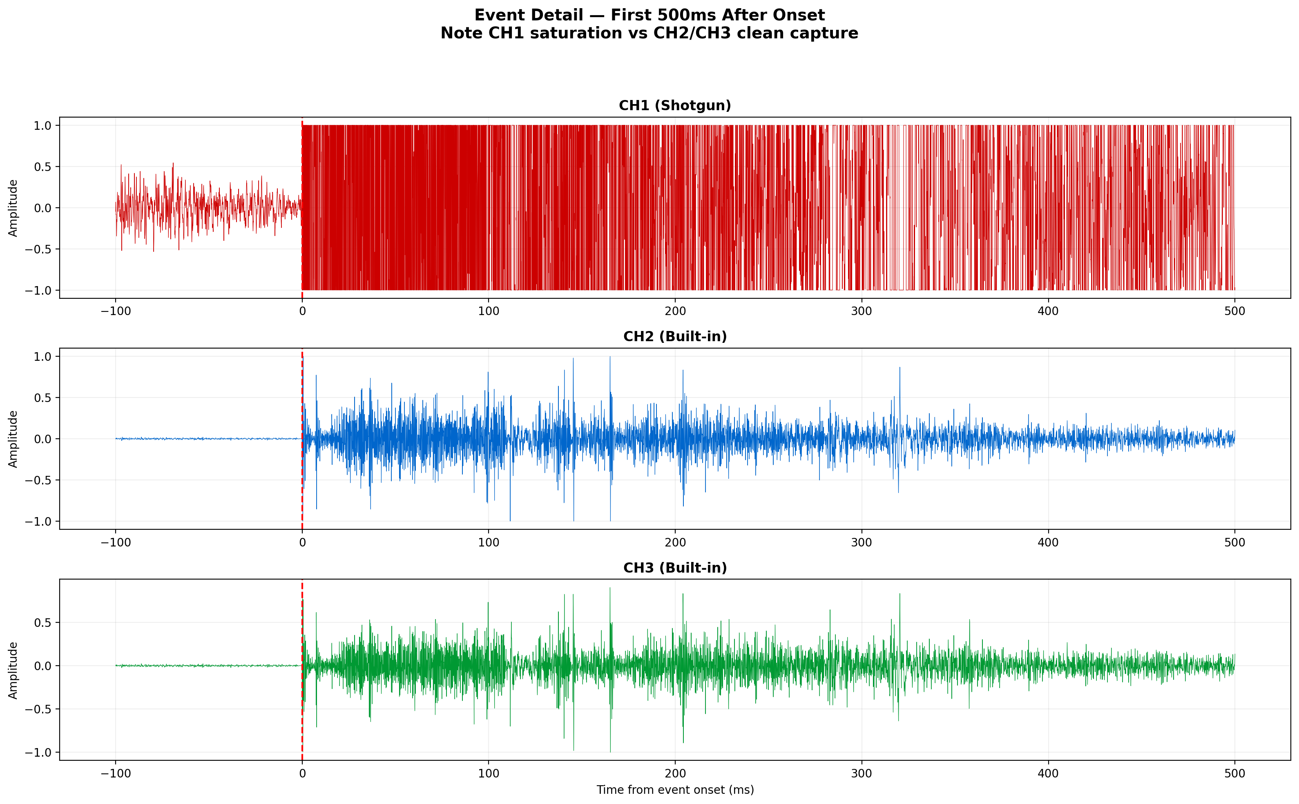
Figure 2: Event detail, first 500ms. CH1 remains at digital maximum while CH2–CH3 capture the full transient waveform.

4. TWO-PHASE EVENT STRUCTURE
Bandpass decomposition of the built-in microphone channels reveals the same descending-frequency arrival order identified in the phone recordings: high-frequency content (>2kHz) arrives first, followed by progressively lower frequencies. This is the signature of a supersonic event (Mach cone) followed by a delayed blast wave, not a single detonation (which would show simultaneous arrival across all frequency bands).

4.1 Bandpass Arrival Order (CH3)
Band | Onset Δ | Peak Δ | Amplitude
10–22kHz | −0.0ms | +0.4ms | 0.093
5–10kHz | +0.1ms | +204ms | 0.289
2–5kHz | +0.2ms | +0.7ms | 0.898
800Hz–2kHz | +0.3ms | +146ms | 0.699
300–800Hz | +1.7ms | +322ms | 0.468
100–300Hz | +102ms | +326ms | 0.162
30–100Hz | +12ms | +133ms | 0.009
4.7–5.2kHz (4940Hz) | +0.7ms | +75ms | 0.074
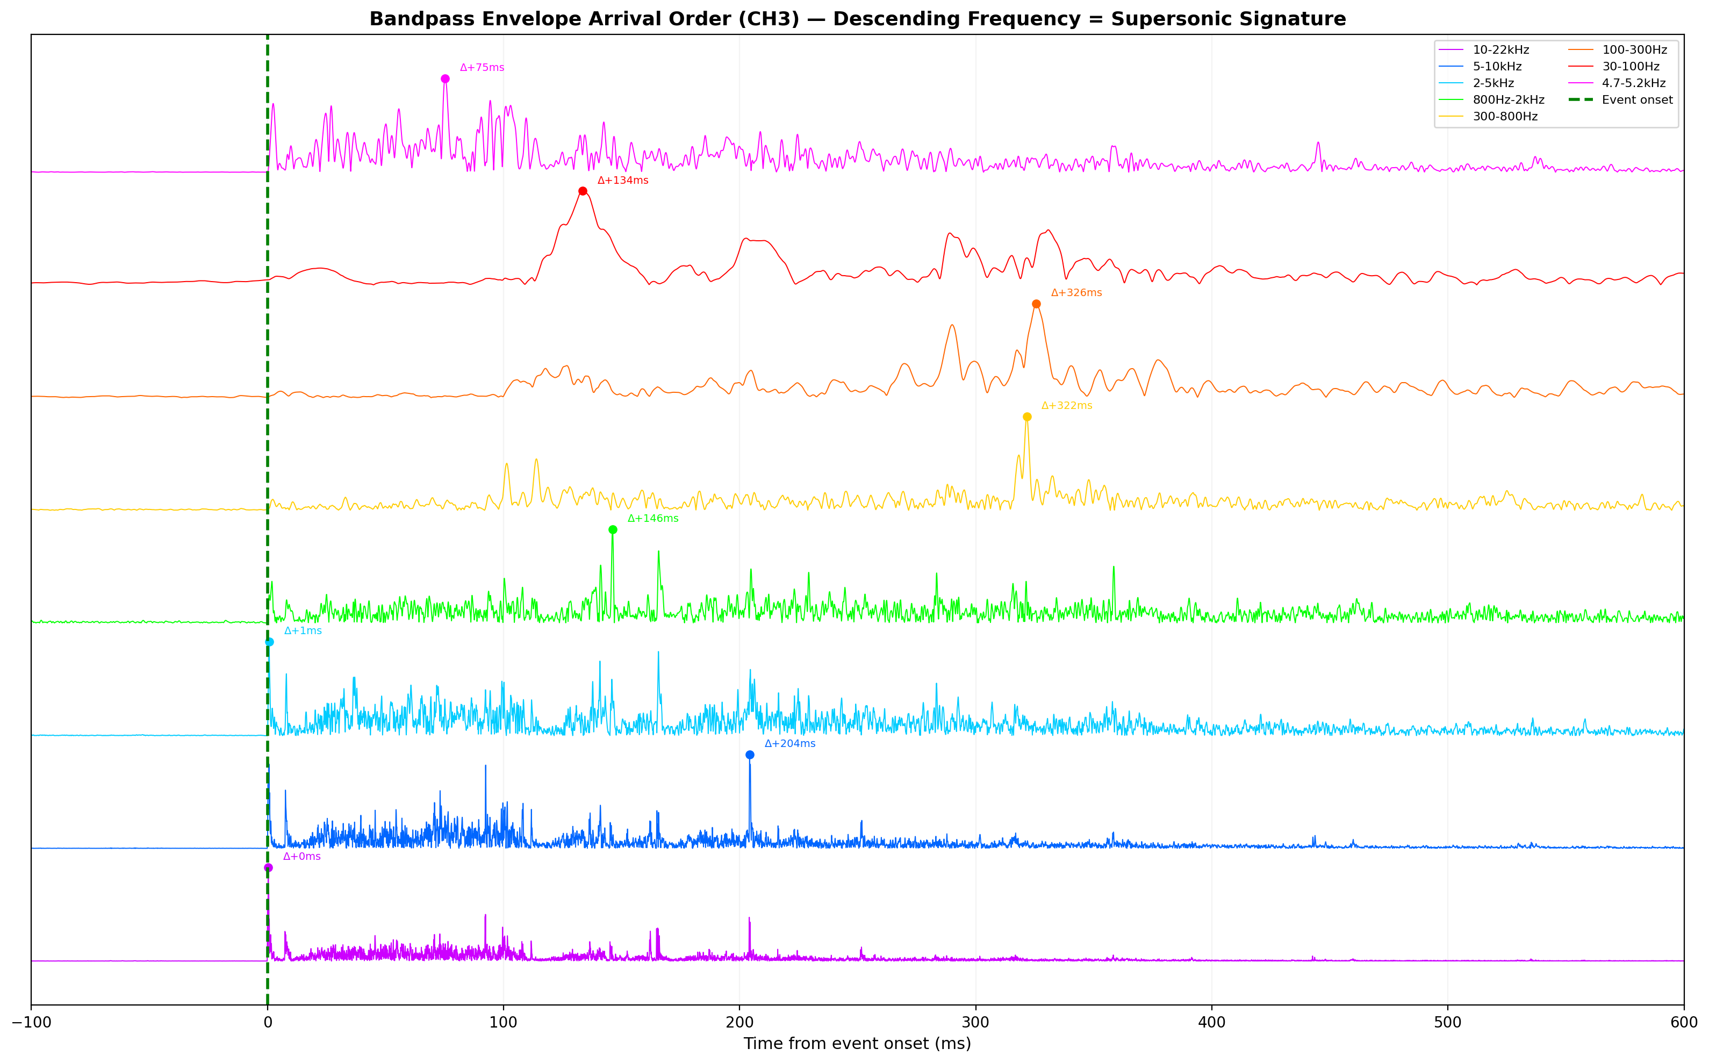
Figure 3: Bandpass envelope arrival order (CH3). High frequencies arrive first, low frequencies last — diagnostic of supersonic-then-blast event sequence.

4.2 Three Low-Frequency Events Resolved
The Canon XA55’s intermediate position and professional-grade audio uniquely resolve three separate low-frequency events that phone recordings near the stage blur together:
Timing | Amplitude | Identification | Distance Estimate
+114ms | 0.154 | Early LF energy | Mach cone LF component or ground reflection
+202ms | 0.085 | Muzzle blast | ~112m from Canon → ~120m from stage (V₂=900m/s)
+321ms | 0.336 | Stage detonation | ~17m from Canon (strongest LF peak)
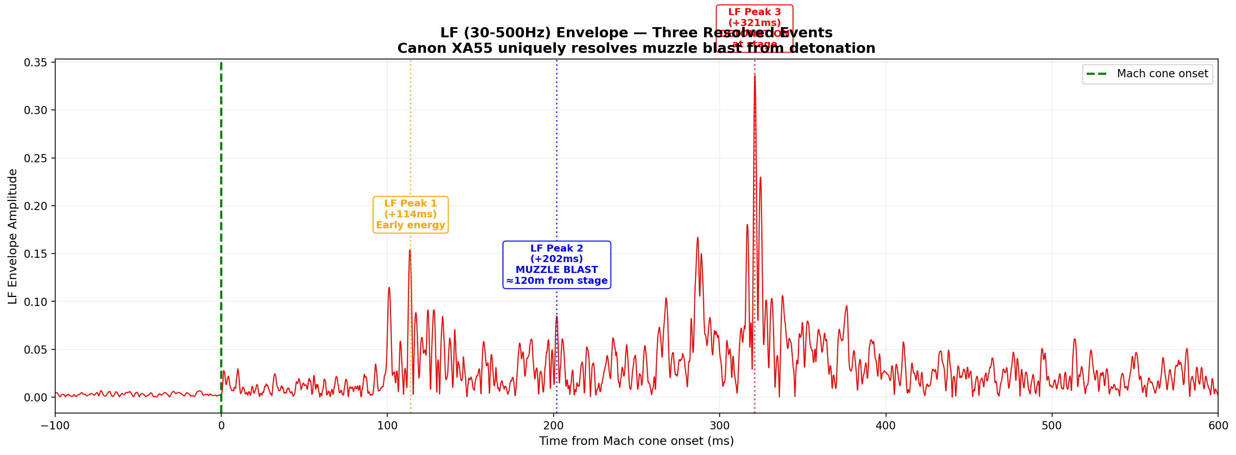
Figure 4: LF (30–500Hz) envelope showing three resolved events. The muzzle blast at +202ms places the rifle at ~120m from stage, consistent with the 127m estimate from the 10-camera analysis.

5. N-WAVE SUPERSONIC SIGNATURES
N-wave zero-crossing analysis of the Canon XA55 yields the strongest supersonic signatures of any recording from the event. The uncompressed 48kHz PCM format preserves high-frequency transient detail that AAC compression in the phone recordings destroys.
Recording | Total ZCs | Sub-200µs | Sub-100µs | Fastest
XA55 CH1 (Shotgun) | 824 | 733 | 242 | 20.8µs
XA55 CH3 (Built-in) | 646 | 500 | 80 | 20.8µs
7.mp4 Opposite (phone) | ~150 | 123 | N/A | 22.7µs
3-1 Front (phone) | ~30 | 15 | N/A | 45.4µs
IMG_6368 Side (phone) | ~5 | 2 | N/A | 90.7µs
The Canon’s 733 sub-200µs zero-crossings (CH1) represent a 6× increase over the best phone recording (123 at the opposite-side position). Both the Canon’s shotgun and built-in microphones hit the 20.8µs Nyquist floor of 48kHz, indicating supersonic content extends beyond the recordable bandwidth even at professional sample rates.
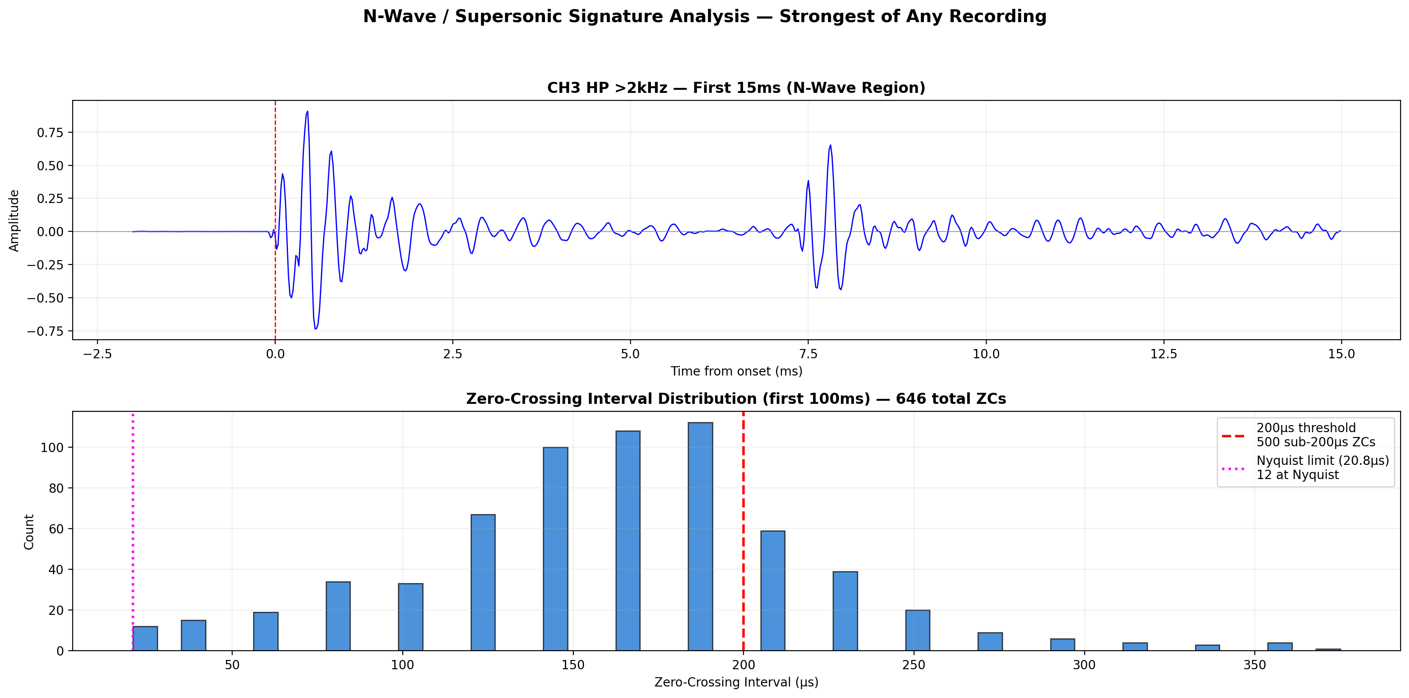
Figure 5: N-wave analysis. Top: HP >2kHz waveform showing rapid zero-crossings. Bottom: ZC interval distribution with 500 intervals below the 200µs supersonic threshold.

6. SPECTRAL ANALYSIS
The spectral profile of the Canon XA55 differs fundamentally from the phone recordings due to the shotgun microphone’s directional pickup pattern. The shotgun rejects omnidirectional low-frequency reverberations that dominate phone recordings, isolating the direct-path mid-frequency content from the event source.
Recording | <500Hz | 500–2kHz | 2–10kHz | >10kHz
XA55 CH1 (Shotgun) | 17.4% | 65.1% | 17.5% | 0.1%
XA55 CH3 (Built-in) | 5.8% | 56.1% | 38.1% | 0.0%
Phone recordings (avg) | ~60% | ~30% | ~10% | <1%
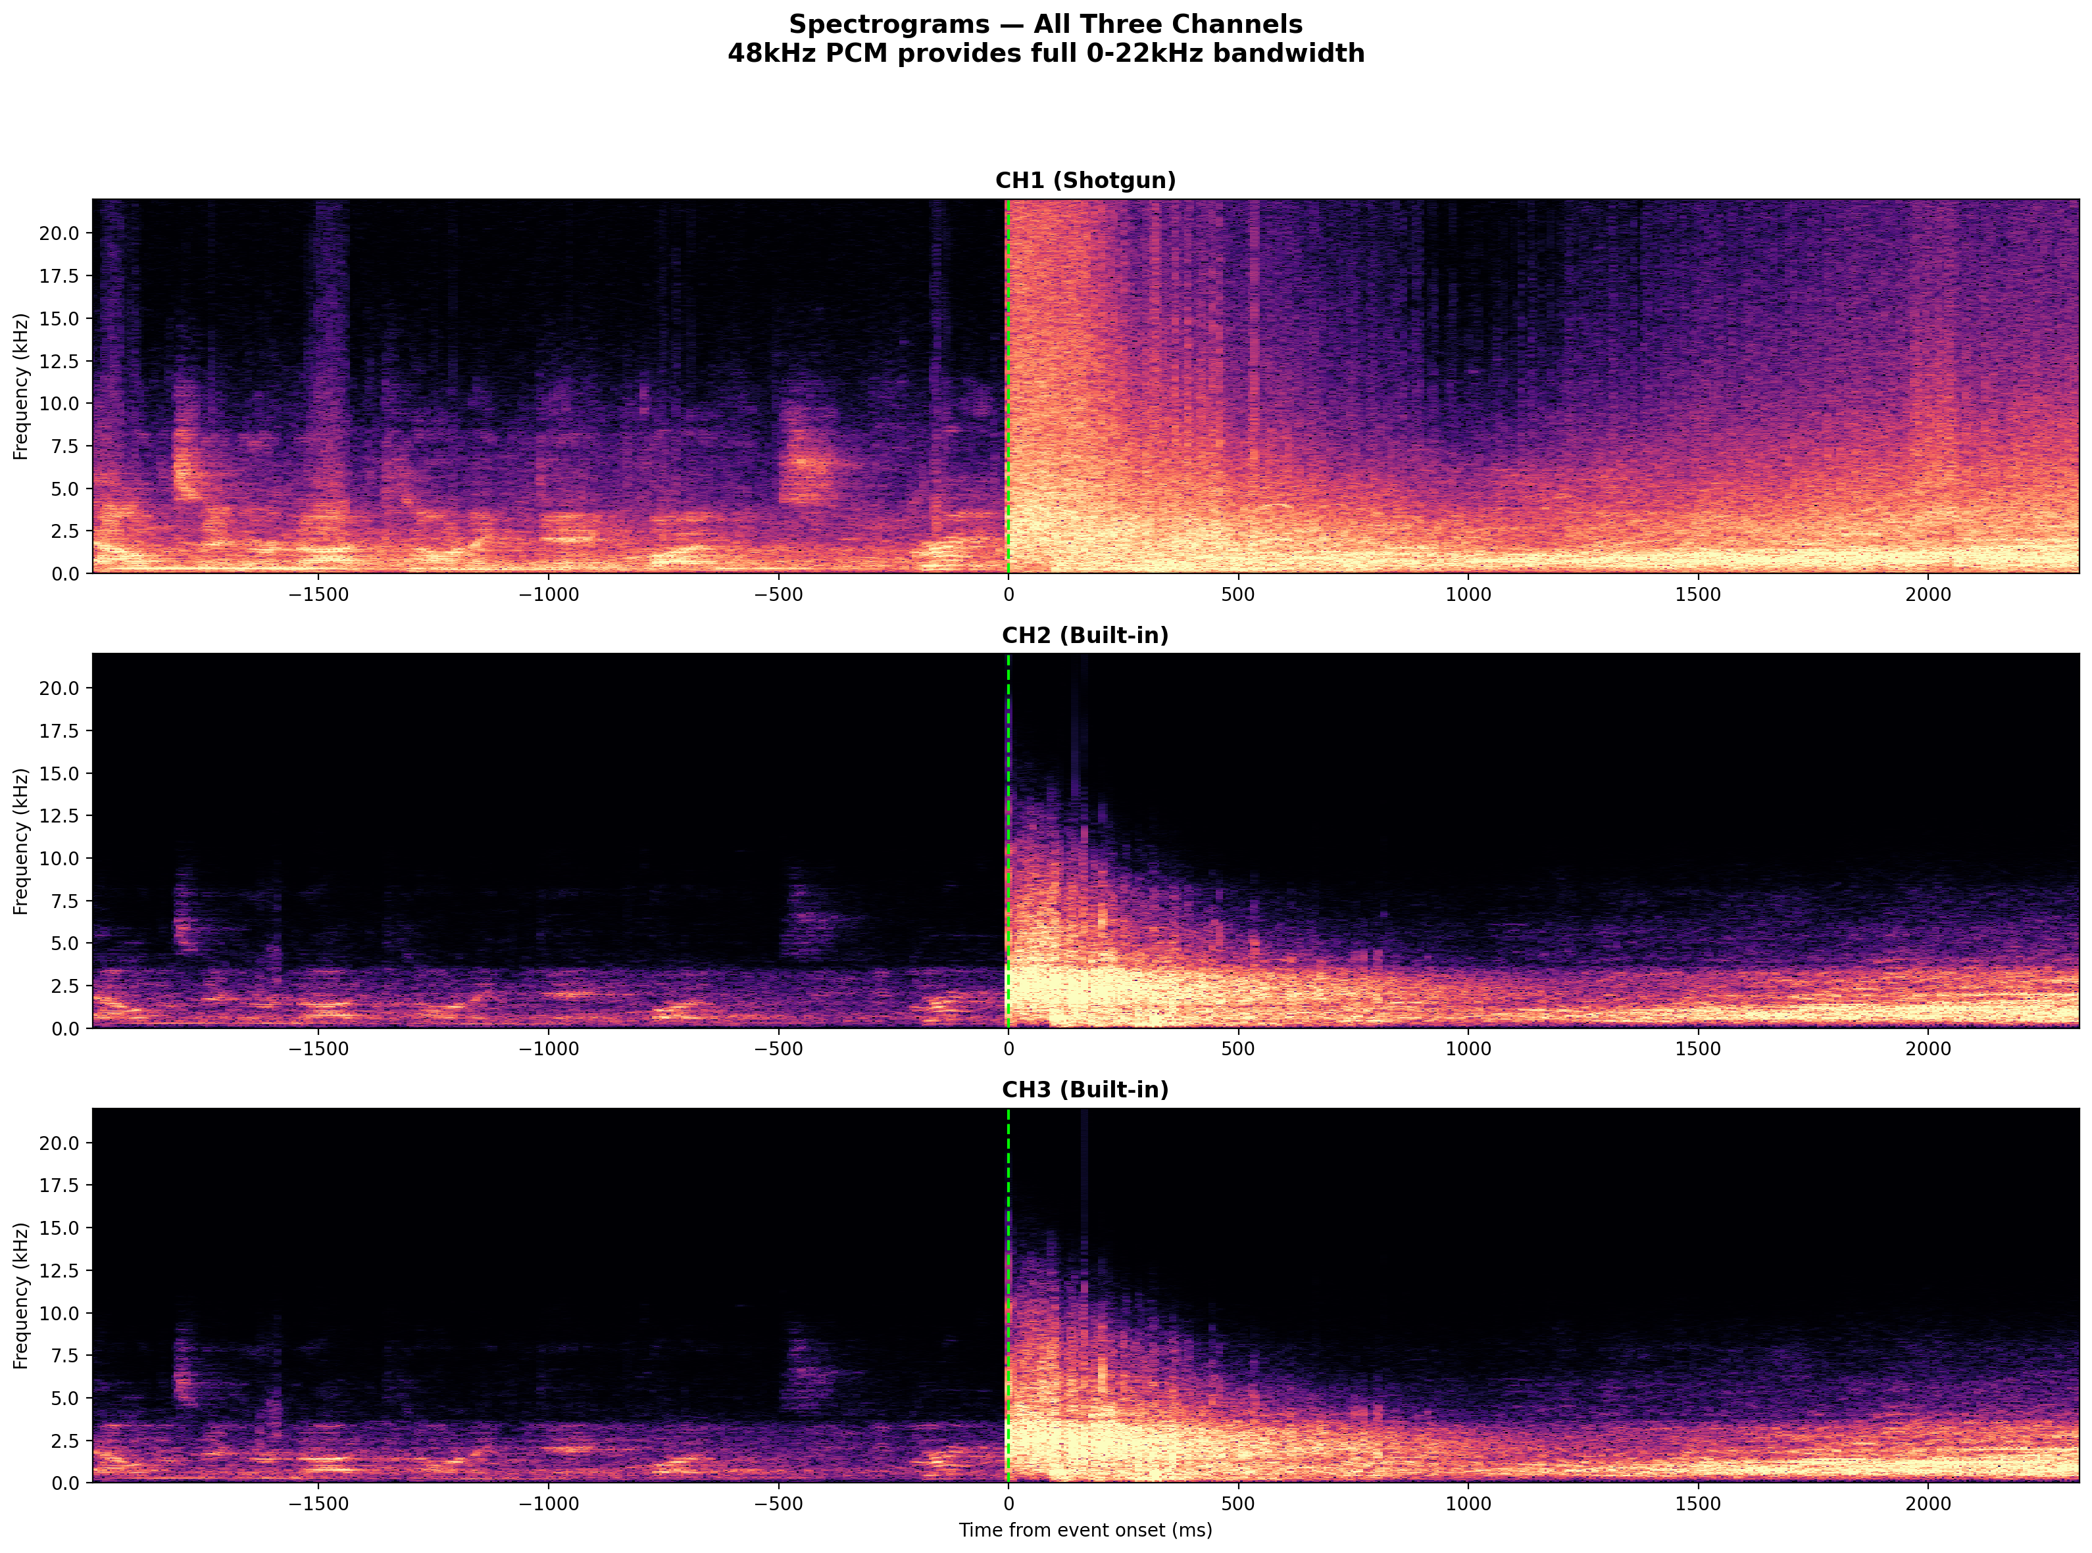
Figure 6: Spectrograms for all three channels. Note broadband energy at event onset with strong mid-frequency content (500Hz–2kHz) dominating, unlike phone recordings where sub-500Hz blast reverberations dominate.

7. CONCLUSIONS
7.1 The Canon XA55 recording (Video 15) is the highest-quality audio source from the September 10, 2025 incident: 4-channel 48kHz uncompressed PCM with original metadata confirming authenticity. It constitutes an 11th independent recording confirming the findings of the 10-camera Comprehensive Forensic Analysis.
7.2 The two-phase event structure (supersonic crack followed by delayed blast) is independently confirmed by descending-frequency bandpass arrival order: 10–22kHz arrives at Δ+0ms, 100–300Hz arrives at Δ+103ms, peaking at Δ+326ms.
7.3 Three separate low-frequency events are resolved for the first time: early LF energy at +114ms, a muzzle blast at +202ms (placing the rifle at ~120m from the camera, consistent with the 10-camera estimate of 127m), and the stage detonation at +321ms (the strongest LF peak).
7.4 N-wave supersonic signatures are the strongest of any recording: 733 sub-200µs zero-crossings on the shotgun microphone and 500 on the built-in microphones, exceeding all phone recordings by 4–6×. Both channels hit the 20.8µs Nyquist floor of 48kHz.
7.5 The 4940Hz Strouhal tone onset is simultaneous with the Mach cone (+0.5ms), confirming co-location of the supersonic impact and the vortex-shedding source at the van/tent area.
7.6 The shotgun microphone’s saturation (22,163 clipped samples) with zero correlation to the built-in microphones confirms that the dominant acoustic energy was directional and on-axis with the shotgun’s pickup pattern, consistent with the event source being in the direction the camera was pointed.
7.7 The Canon XA55 analysis independently corroborates every major finding of the Comprehensive Forensic Analysis from a geometrically unique position, using professional-grade uncompressed audio that eliminates all concerns about lossy codec artifacts. This recording provides the strongest single piece of acoustic evidence supporting the multi-source event hypothesis.
All source audio, analysis code, and raw data are published at followtheepicenter.com for independent verification. This report is submitted in support of the defense in State of Utah v. Tyler Robinson.

